

Informatics Institute of Technology

BEng (Hons) Software Engineering

Machine Learning and Data Mining

5DATA001C.2

Analyses Report of Two Case Studies, Predicting Cancer  
Patients Mortality Status and Survival Months

Student Name: Pahandi Samarasinghe

IIT ID: 20231228

UOW ID: w2052243

Tutorial Group: SE-10

Table of Contents

CASE STUDY A – Predicting Cancer Patients Mortality Status 4

Task A.1 – Domain Understanding: Classification 4

Task A.2 – Exploring and Understanding Your Dataset 5

Task A.3 – Data Preparation 7

(a) Cleaning Issues & Fixes 7

(b) Before & After Evidence 8

Task A.4 – Classification Modelling 10

(a) Algorithms 10

(b) Training-Test Split 10

Task (5) – Evaluating your Cancer Mortality Status Classification Models 12

(a) Evaluation Outputs 12

(b) Metric Analysis 15

(c) Best Model Recommendation 16

(d) Hyperparameter Tuning 16

(e) Critique and Limitations of the Best-Performing Model (Logistic Regression) 18

(f) Ensemble Learner 18

CASE STUDY (B) Analyses Report for Predicting Survival Months Tasks 23

Task (1) – Domain Understanding and Designing Your Regression Experiments 23

Task (2) – Modelling: Build Predictive Regression Models 23

(a) Benefits of Using Decision Trees 23

(b) DT-1 vs DT-2 Implementation 24

(c) Visualize Trees 25

Task (3) – Evaluating your Cancer Survival Months DT Regression Models. 27

(a) Regression Metric Analysis 27

(b) Best Model Recommendation 28

(c) Concerns About Metrics 28

Task (4) – Interpreting Cancer Survival Months Decision Tree Outcomes 29

(a) Prediction of Survival Months for Patient B002565 29

References 30

Table of Figures

Table 1:Variable RETAIN DROP Table 4

Table 2:Variable issue Table 7

Table 3:parametric and non-parametric algorithms 10

Table 4:classification evaluation metrics table 15

Table 5:egression evaluation metric table 27

Table of Figures

Figure 1:Descriptive statistics 6

Figure 2:Data types 6

Figure 3:Class distribution (Alive vs. Dead bar plot) 7

Figure 4:null values before 9

Figure 5:null values after 9

Figure 6:mortilaty status before 9

Figure 7:mortilaty test after 9

Figure 8:age distribution before 9

Figure 9:age distribution after 10

Figure 10:Tumour size before 10

Figure 11:Tumour size after 10

Figure 12: Training test features 11

Figure 13: LR Confusion matrix 13

Figure 14: LR classification report 13

Figure 15:LR ROC Curve 13

Figure 16: KNN confusion matrix 14

Figure 17:KNN Classification report 14

Figure 18:KNN ROC Curve 14

Figure 19:NB Classification report 15

Figure 20:NB Confusion Matrix 15

Figure 21:NB ROC Curve 15

Figure 22:LR confusion matrix before tunning 17

Figure 23:LR confusion matrix after tunning 17

Figure 24: tuned LR classification report 18

Figure 25:Tuned LR ROC Curve 18

Figure 26: Python code for ensemble learner 19

Figure 27:KNN confusion matrix 20

Figure 28:LR Confusion matrix 20

Figure 29:Ensemble classifier Confusion matrix 20

Figure 30:LR ROC Curve 21

Figure 31:KNN ROC Curve 21

Figure 32: Ensemble Classifier ROC Curve 21

Figure 33:LR Classification report 22

Figure 34:KNN classification report 22

Figure 35: ensemble Learner classification report 22

Figure 36: Regression dataset shape and feature names 24

Figure 37:python code for fully grown DT 25

Figure 38: Python code for tuned DT 25

Figure 39:DT-1 26

Figure 40:DT-2 27

|  |  |  |
| --- | --- | --- |
| **Variable Name** | **RETAIN or DROP** | **Brief justification for retention or dropping** |
| Patient ID | DROP | Just an identifier, no predictive value |
| Month of Birth | DROP | Not medically relevant for mortality prediction. |
| Age | RETAIN | Age is clinically relevant in breast cancer outcomes. |
| Sex | DROP | Dataset is predominantly female, limited variability |
| Occupation | DROP | Limited evidence of direct impact on mortality |
| T Stage | RETAIN | Indicates tumor size, a key predictor. |
| N Stage | RETAIN | Lymph node involvement is crucial in prognosis. |
| 6th Stage | RETAIN | Provides clinical staging info. |
| Differentiated | RETAIN | Shows how aggressive the cancer cells are. |
| Grade | RETAIN | Tumor grade is a known risk factor. |
| A Stage | RETAIN | Indicates regional or distant spread. |
| Tumour Size | RETAIN | Larger tumors associate with poorer prognosis |
| Estrogen Status | RETAIN | Hormone receptor status impacts survival. |
| Progesterone Status | RETAIN | Hormone receptor status influences treatment response and survival |
| Regional Node Examined | RETAIN | More nodes effects to better staging and impacts decisions. |
| Regional Node Positive | RETAIN | Metastasis indicator and a critical factor |
| Survival Months | RETAIN | This is an outcome variable for regression, not classification |
| Mortality Status | RETAIN (Target) | This is the classification target. |

**CASE STUDY A – Predicting Cancer Patients Mortality Status**

Table :Variable RETAIN DROP Table

## Task A.1 – Domain Understanding: Classification

## Task A.2 – Exploring and Understanding Your Dataset

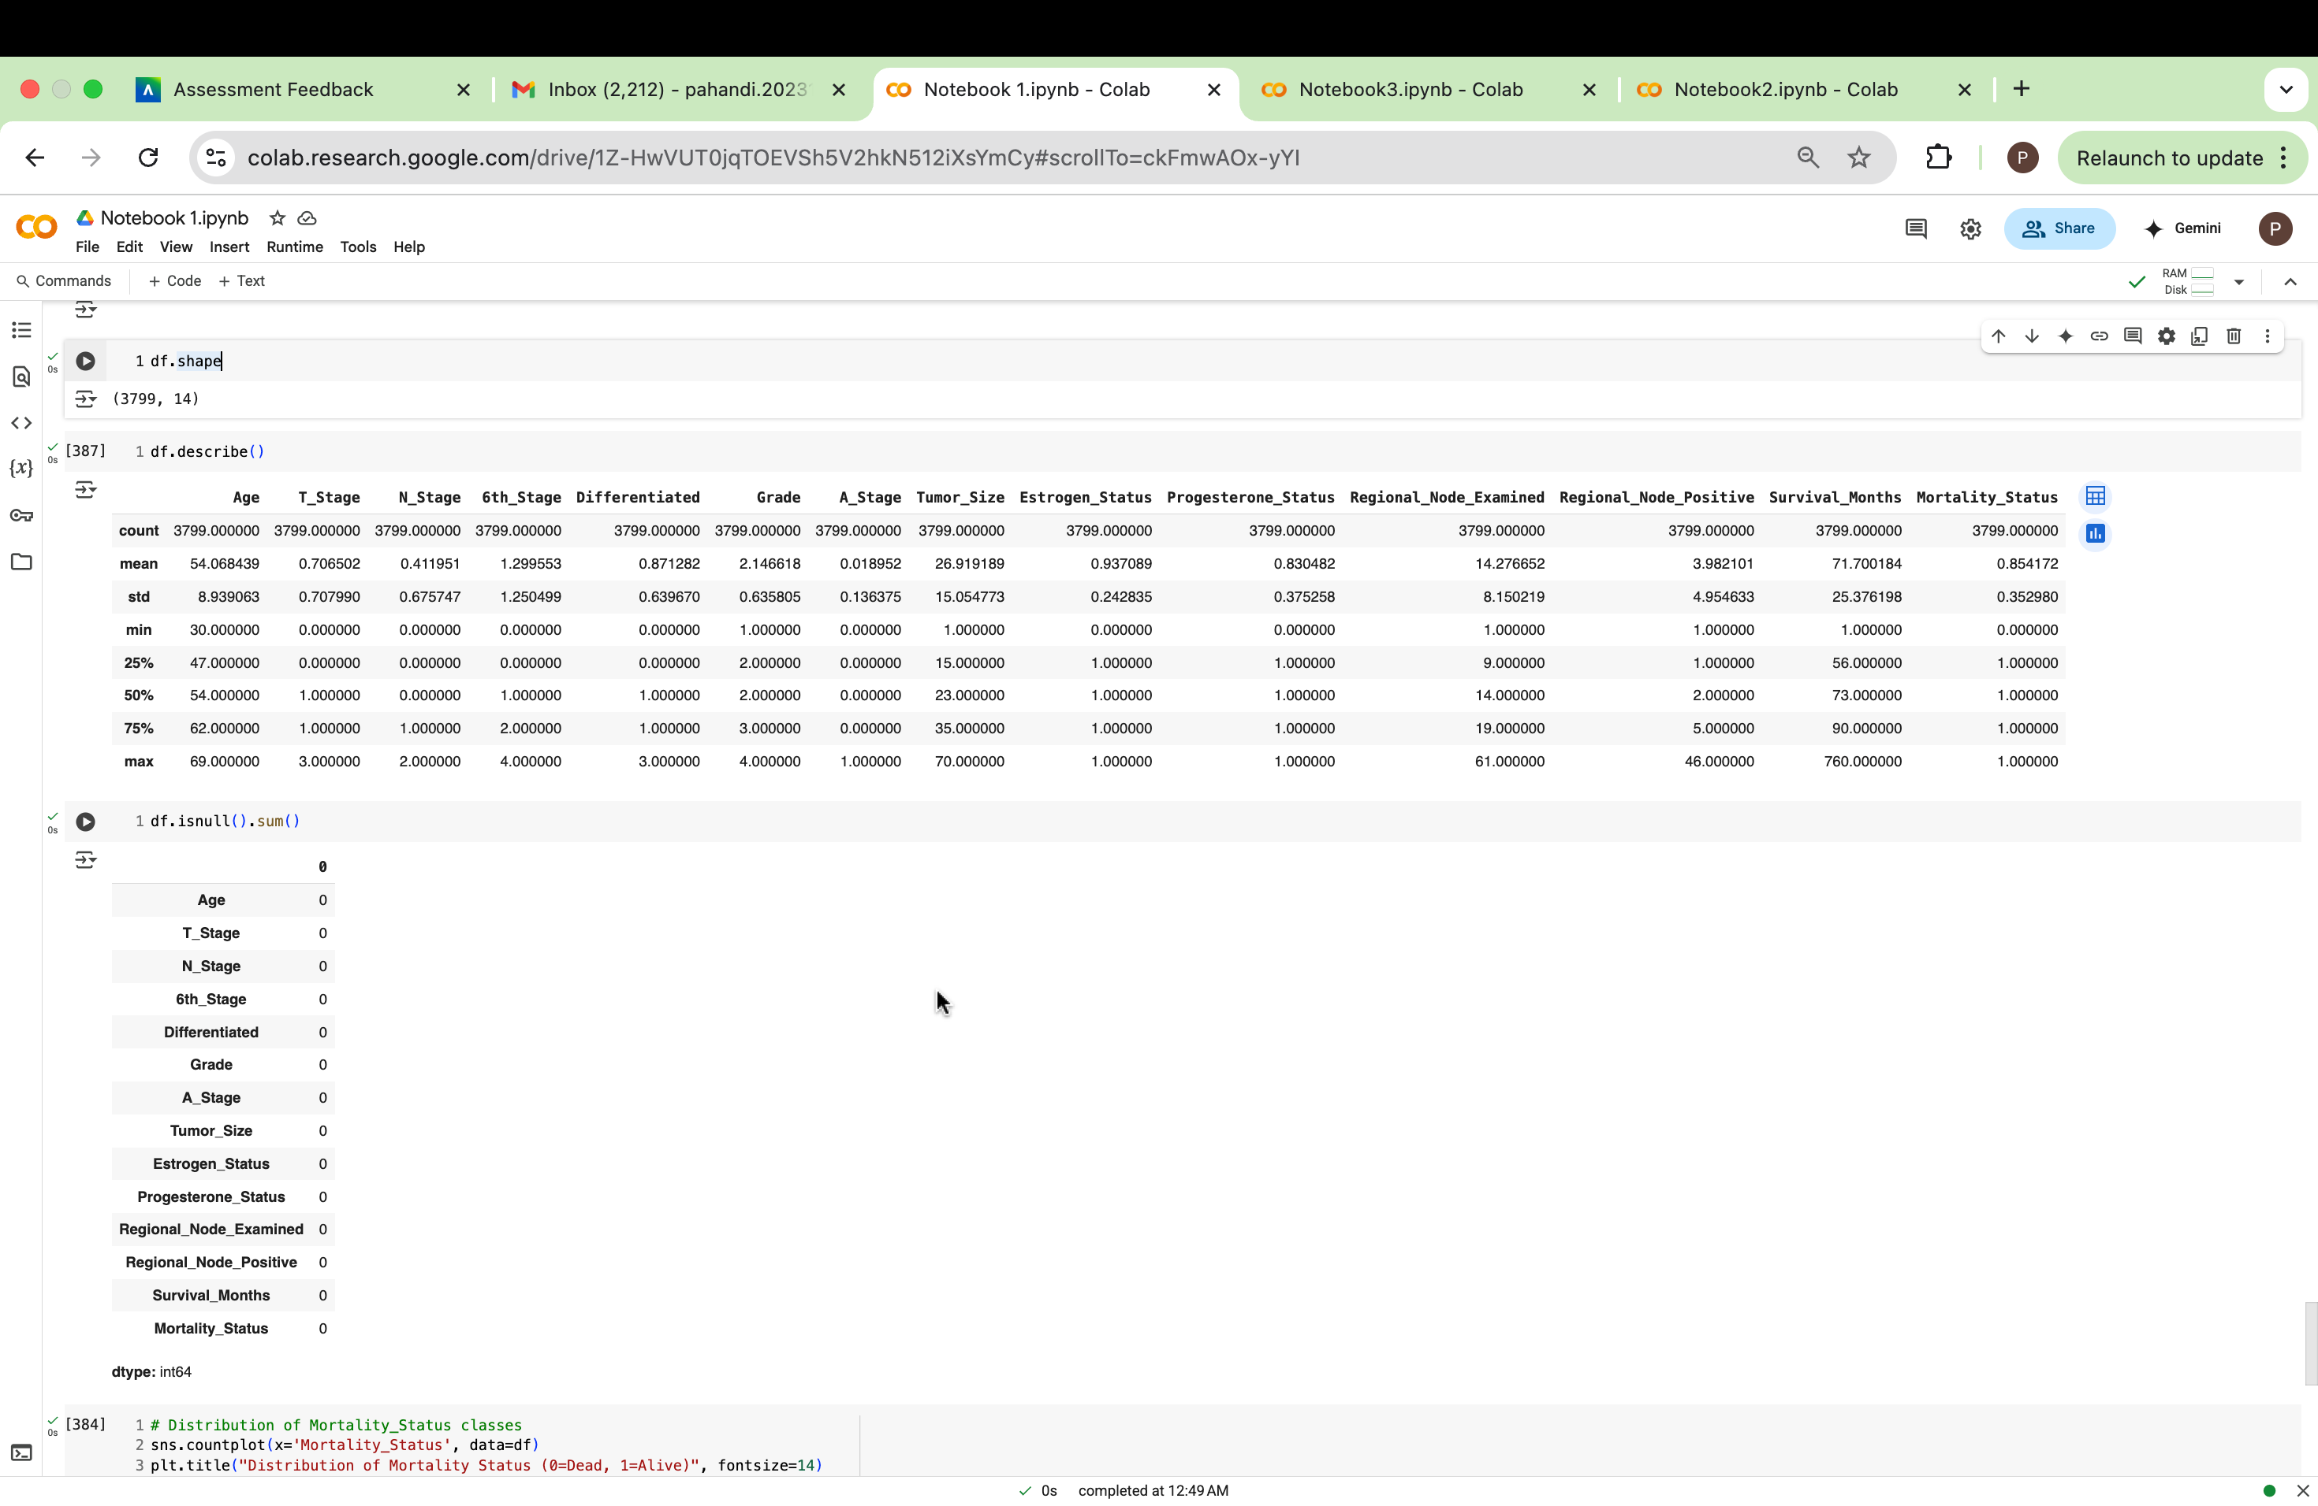

Figure 1:Descriptive statistics



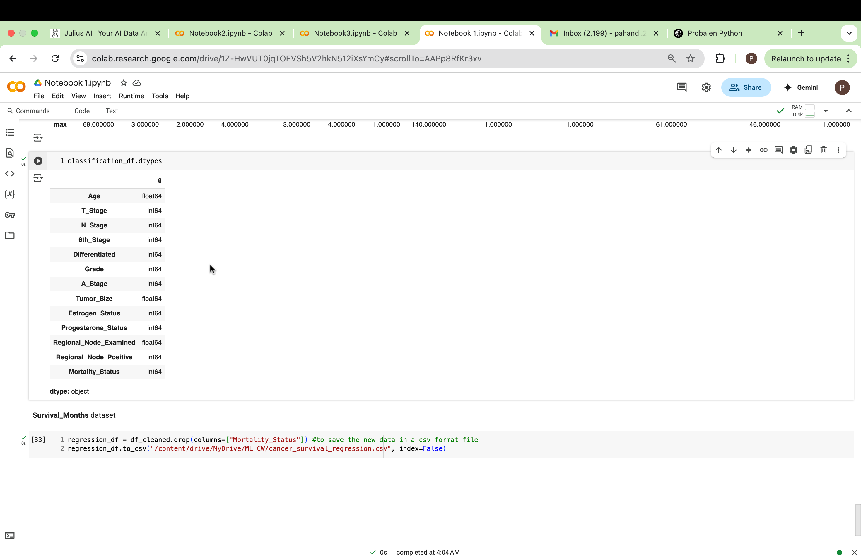

Figure :Data types

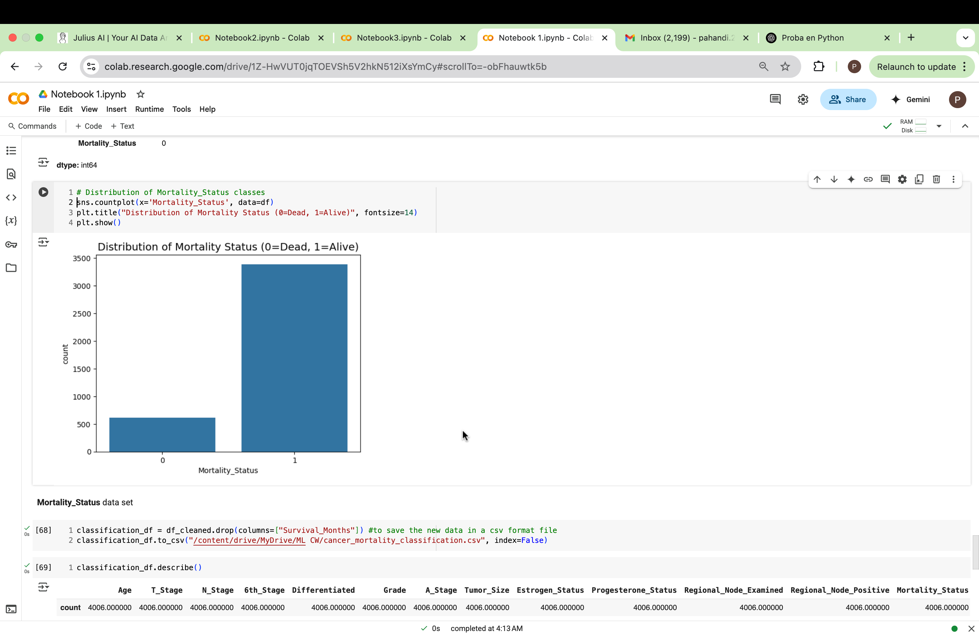

Figure 3:Class distribution (Alive vs. Dead bar plot)

## Task A.3 – Data Preparation

# (a) Cleaning Issues & Fixes

|  |  |  |  |
| --- | --- | --- | --- |
| Variable Name | Issue found | Proposed fix | Justification for used fix method |
| Age | 9 missing values | Impute with **median** age | Age is a critical clinical variable; median is robust against outliers. |
| Tumour Size | 3 missing values | Impute with median | Continuous data with potential skew; median is best |
| Regional_Node_Examined | 1 missing value | Dropped | Dropped since just one value is null |
| Mortality_Status | Inconsistent string formats (e.g. 'ALIVE', 'dead') | Standardize to consistent strings ('Alive'/'Dead') | Ensures consistent binary classification |
| Age | Potential scale issues and outliers | Detect outliers; apply standard scaling | Ensures comparability between features and models |
| Tumour Size | Potential scale issues and outliers | Detect outliers; apply standard scaling | Ensures comparability between features and models |
| Reginol_Node_Positive | Column Typo | Rename to Regional_Node_Positive | Ensures correct referencing of feature |
| T_Stage | Categorical string (‘T1’, ‘T2’, etc.) | Encode: T1–T4 → 0–3 | Converts ordinal stage to numeric format for ML |
| N_Stage | Categorical string (‘N1’, ‘N2’, etc.) | Encode: N1–N3 → 0–2 | Numeric encoding for ordinal lymph node stage |
| 6th_Stage | Multiple stage categories (‘IIA’, ‘IIIB’, etc.) | Encode into ordinal values (e.g., IIA = 0, IIIC = 4) | Preserves stage progression for modeling |
| Differentiated | Text-based class labels | Encode: Poorly = 0, Moderate = 1, Well = 2, Undiff. = 3 | Converts qualitative severity to numerical scale |
| A_Stage | Categorical: Regional vs Distant | Encode: Regional = 0, Distant = 1 | Binary encoding suitable for ML |
| Estrogen_Status | Categorical: Positive/Negative | Encode: Positive = 1, Negative = 0 | Converts binary hormone status to numeric |
| Progesterone_Status | Categorical: Positive/Negative | Encode: Positive = 1, Negative = 0 | Binary encoding suitable for ML |

Table :Variable issue Table

# (b) Before & After Evidence

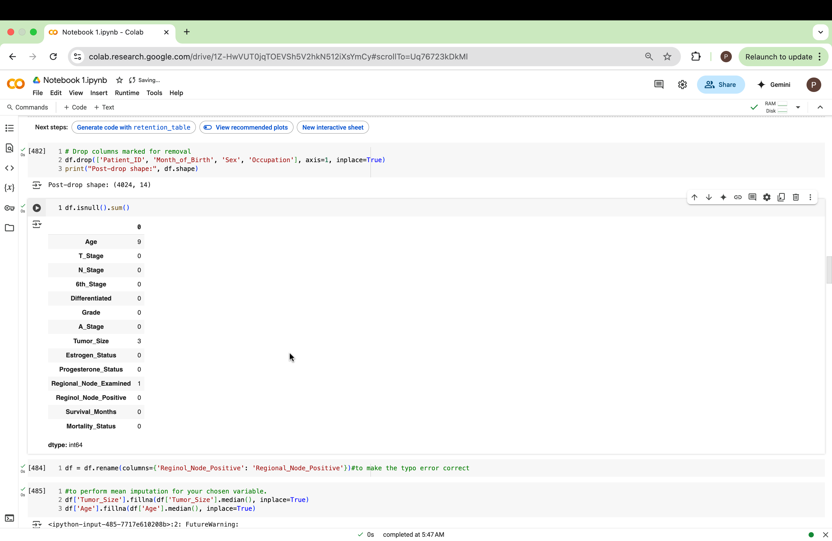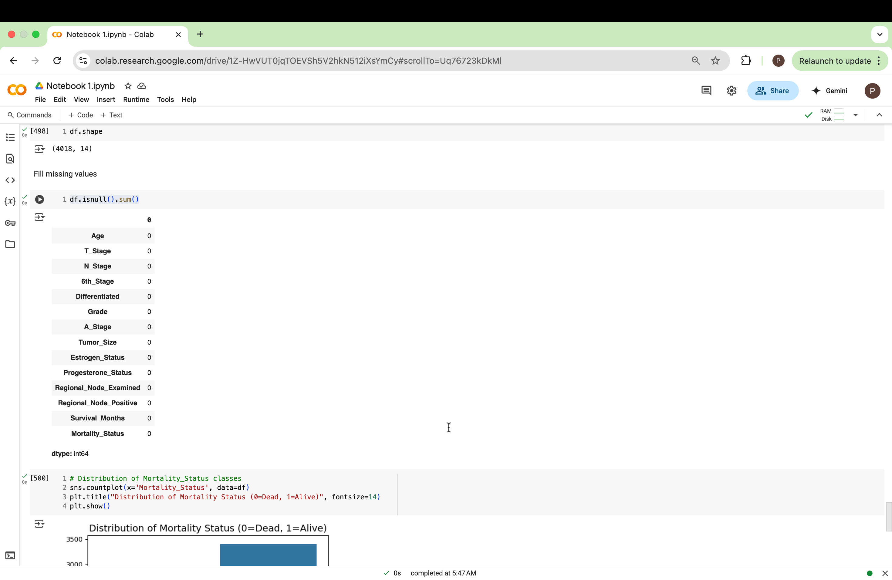

Figure 4:null values before

Figure 5:null values after

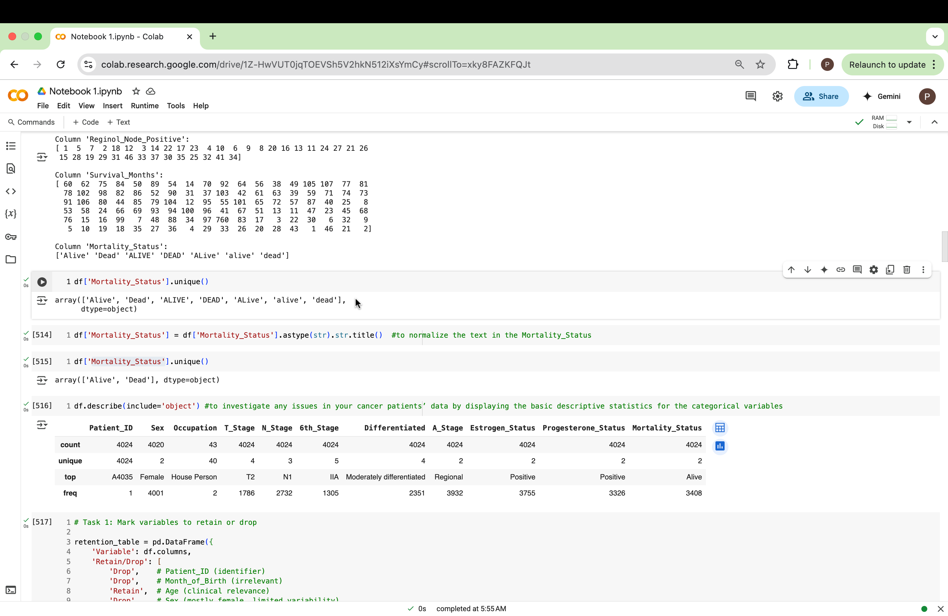

Figure 6:mortilaty status before



Figure 7:mortilaty test after

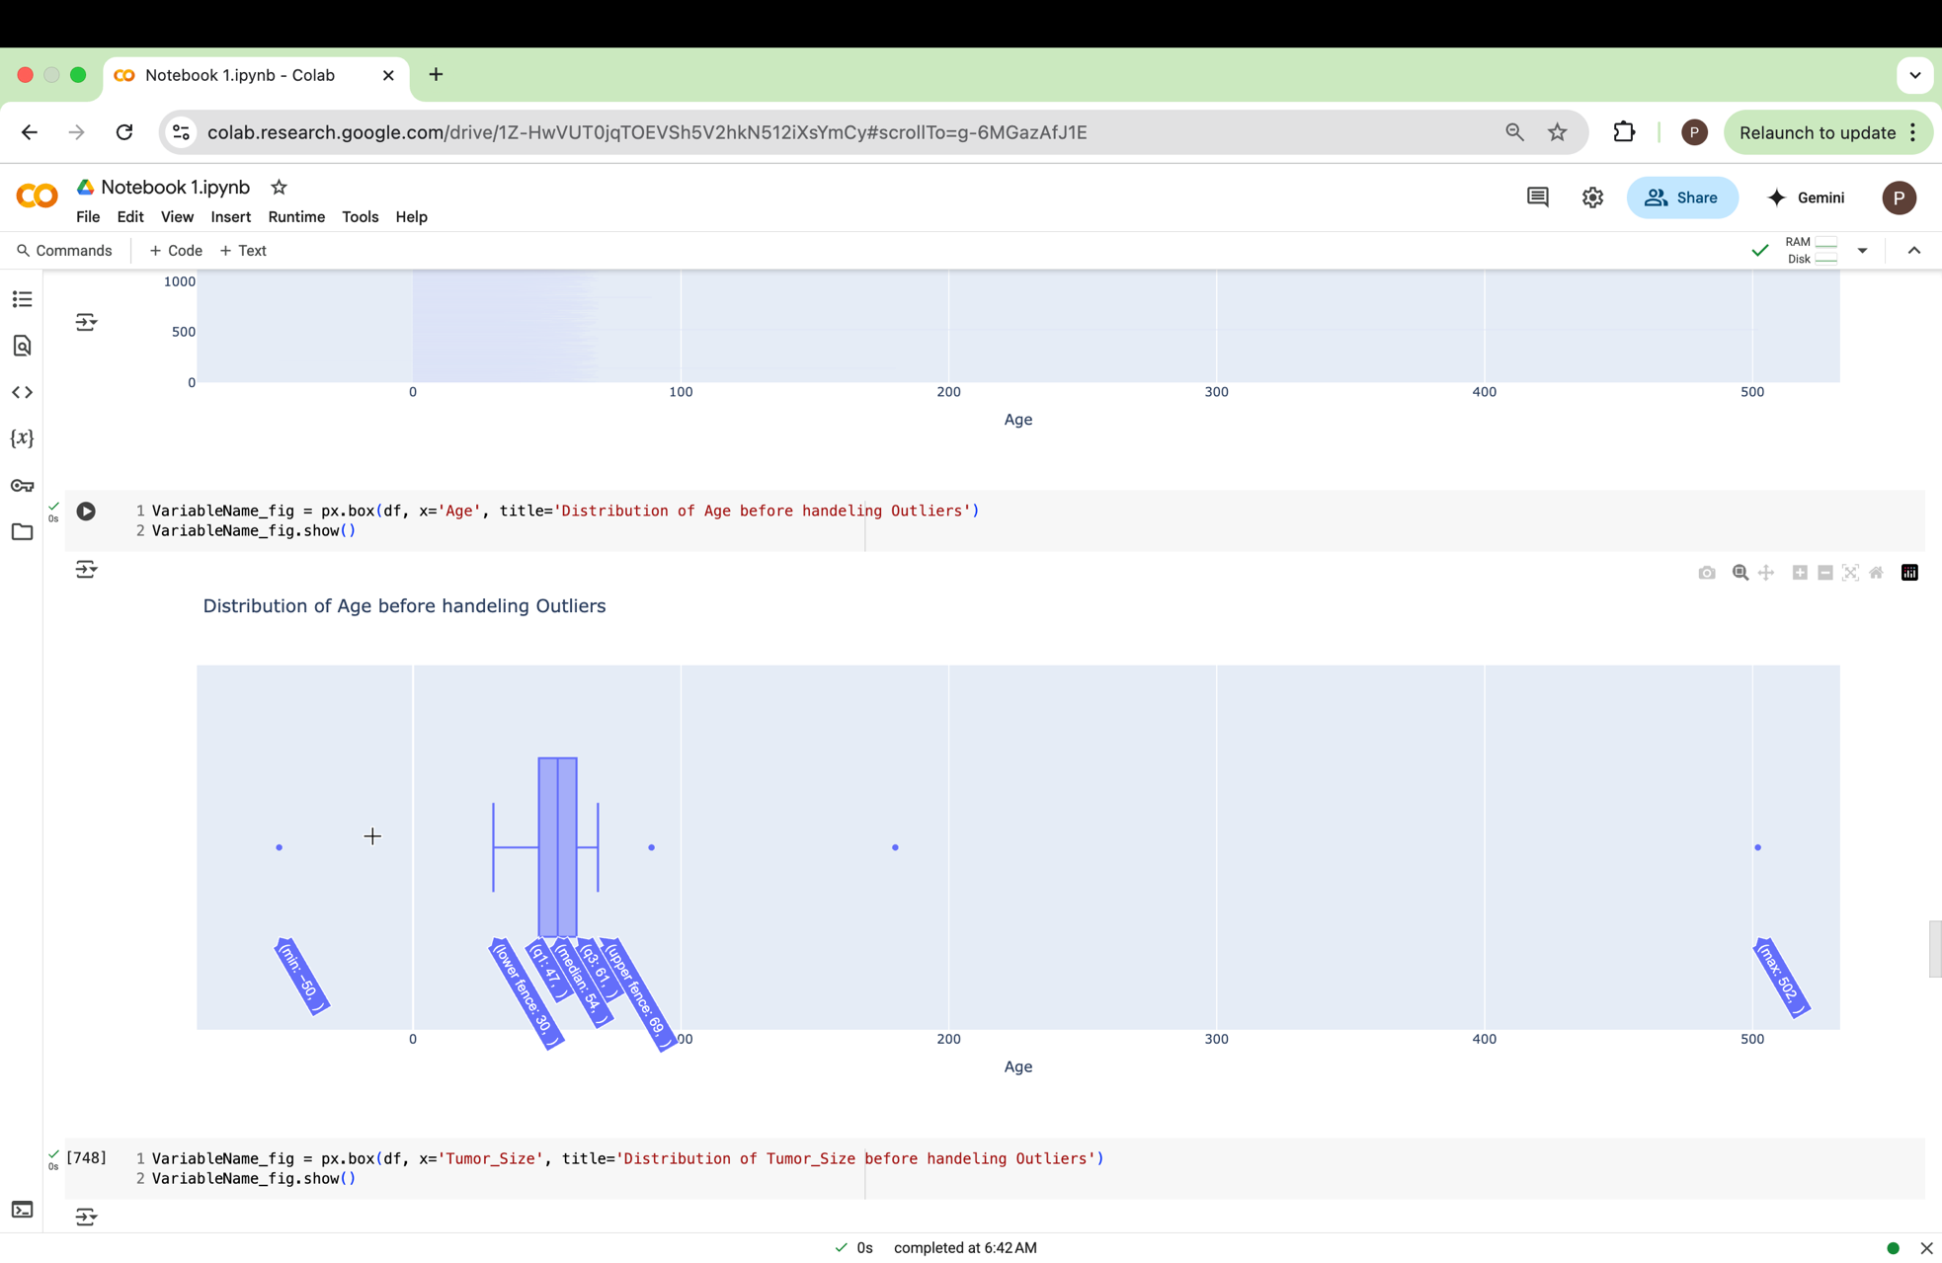

Figure 8:age distribution before

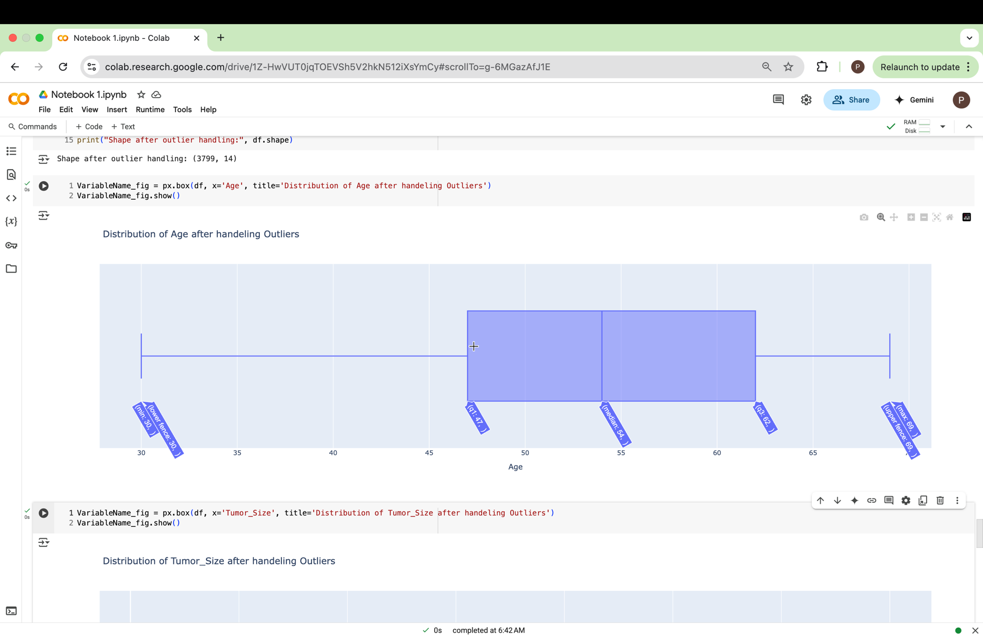

Figure 9:age distribution after

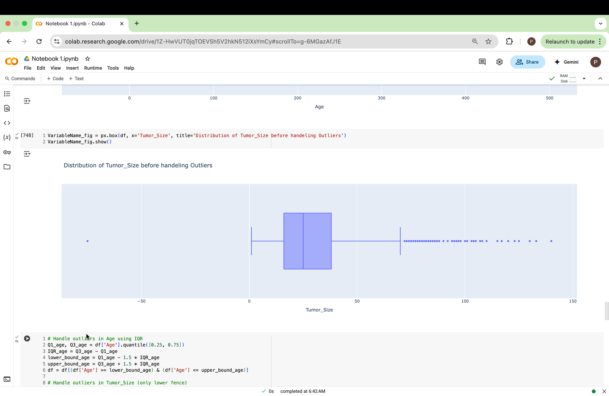

Figure 10:Tumour size before

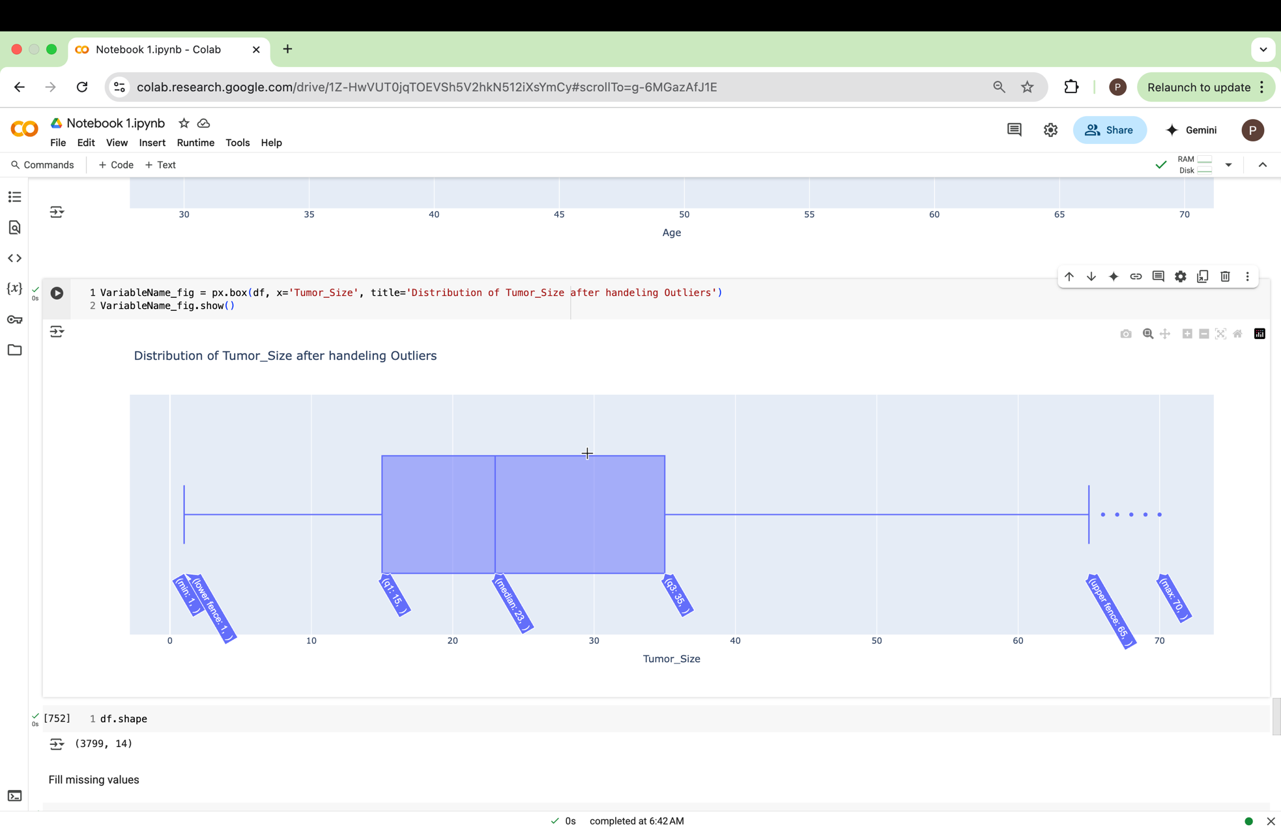

Figure 11:Tumour size after

## Task A.4 – Classification Modelling

# (a) Algorithms

|  |  |  |  |
| --- | --- | --- | --- |
| **Algorithm Name** | **Algorithm Type** | **Learnable Parameters** | **Some Strategic Hyperparameters** |
| NB | Parametric | Class-conditional means and variances | var_smoothing (tested: 1e-9, 1e-8, 1e-7) |
| LR | Parametric | Weights, bias | C (tested:0.001, 0.01, 0.1, 1, 10, 100), solver (liblinear/lbfgs) |
| KNN (N=9) | Non-Parametric | None | n_neighbors (3–13), weights (uniform/distance) |

Table :parametric and non-parametric algorithms

# (b) Training-Test Split

i. Features & Shape Screenshot

Figure 12: Training test features

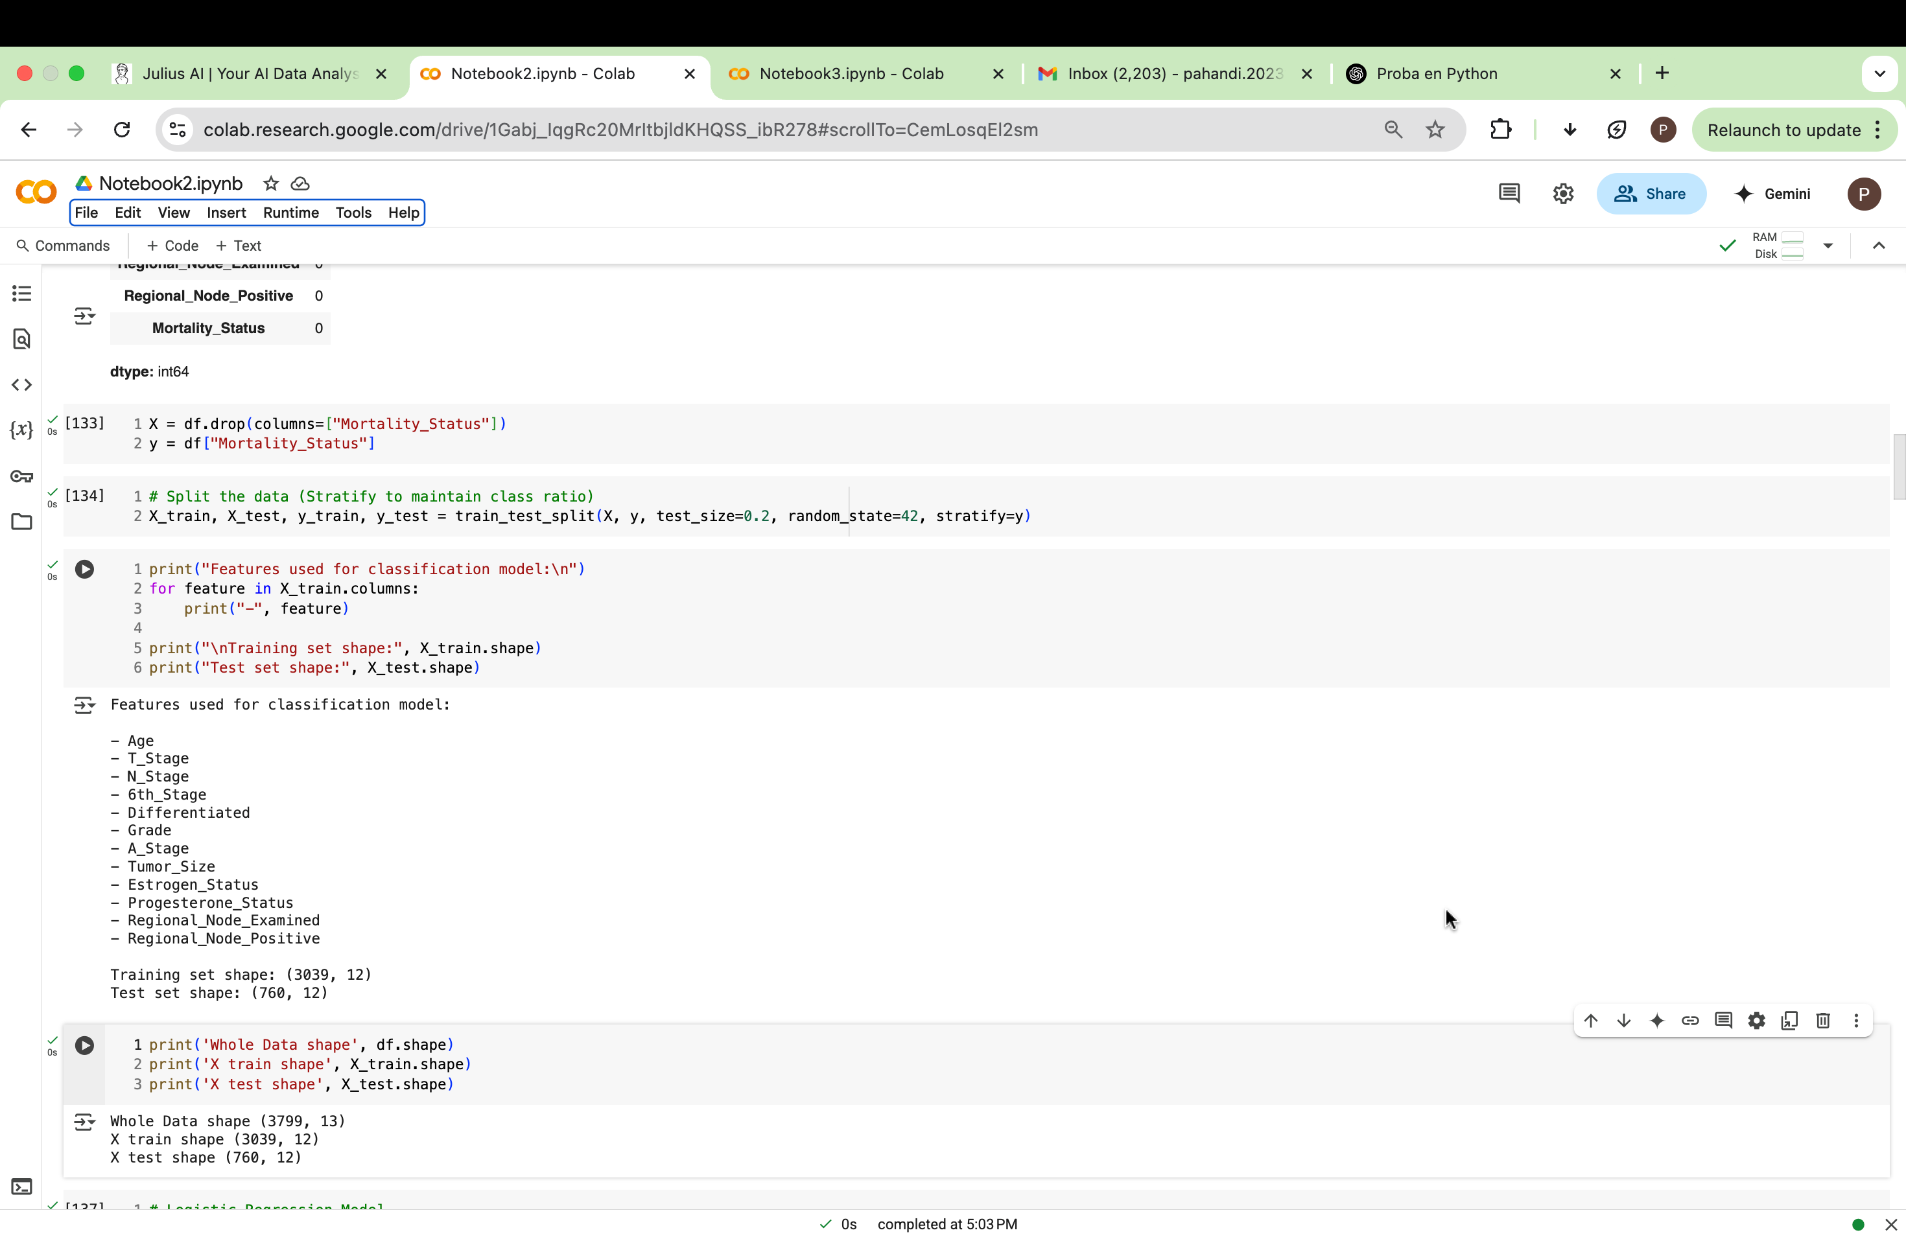

ii. Justification

An 80/20 training-test split was used in this classification experiment, with stratification applied to preserve the class distribution of the target variable, Mortality_Status. This ratio is a widely accepted standard in supervised machine learning tasks as it provides a balanced compromise between having enough data to train the model effectively and retaining sufficient data to evaluate its performance objectively (Scikit-learn.org, 2013). The use of stratify=y ensures that the class imbalance (i.e., unequal numbers of "Alive" and "Dead”) cases is proportionally reflected in both the training and test sets. Without stratification, the model could be trained on a skewed class distribution, leading to biased performance metrics and poor generalization. Maintaining this balance is particularly important in medical classification problems, where one class (such as mortality) may be underrepresented but critically important to predict accurately

iii. Train-Test Stratification

The training-test split code in the Final Python Notebook 2 ensures two critical conditions are met. First, using random_state=42 guarantees that all models are evaluated on the same test subset. This removes randomness and ensures fair comparison between classifiers (Lee, 2023). Second, setting stratify=y preserves the ratio of “Alive” to “Dead” cases in both the training and test sets. This is essential because breast cancer mortality is an imbalanced classification problem; without stratification, one set may have a disproportionate number of deaths or survivals, biasing the results. Applying both settings supports model fairness, reproducibility, and reliability especially in medical applications where each patient prediction is critical.

## Task (5) – Evaluating your Cancer Mortality Status Classification Models

# (a) Evaluation Outputs

Logistic Regression LR

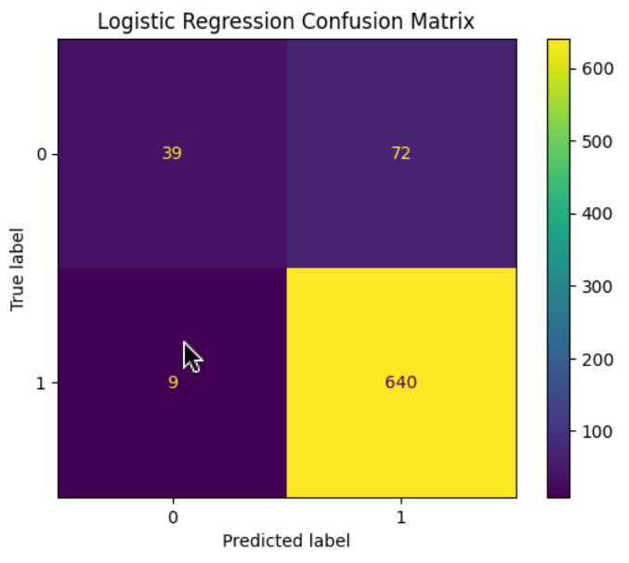

Figure : LR Confusion matrix

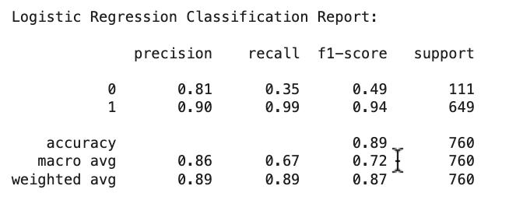

Figure : LR classification report

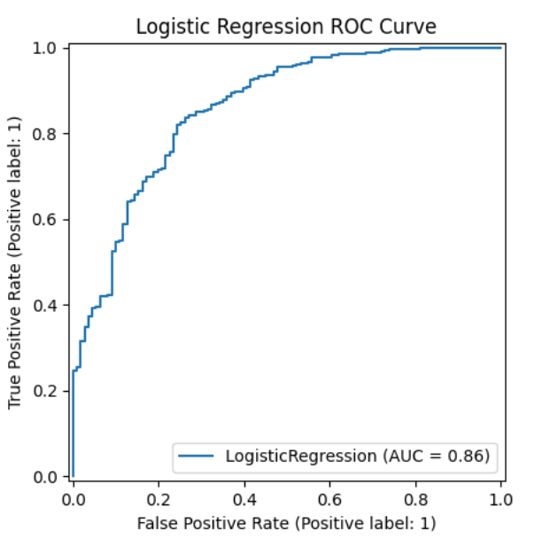

Figure :LR ROC Curve

KNN

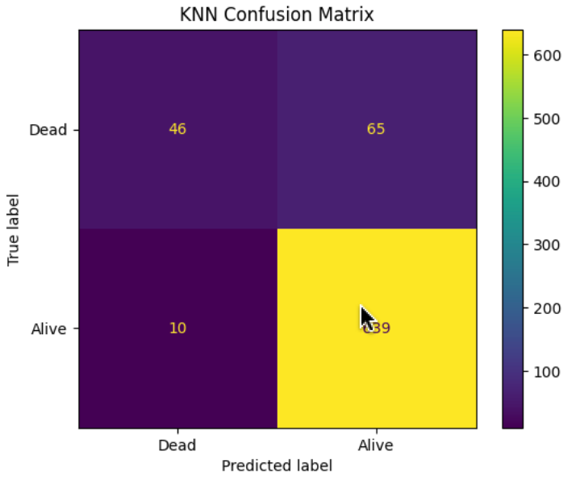

Figure : KNN confusion matrix

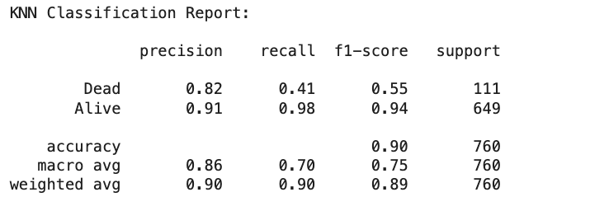

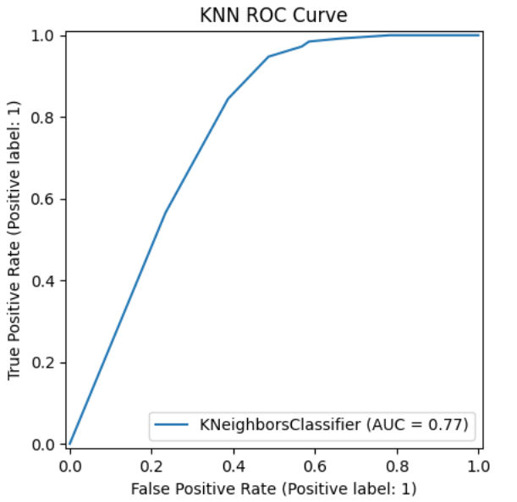

Figure :KNN Classification report

Figure :KNN ROC Curve

Naive Bayes NB

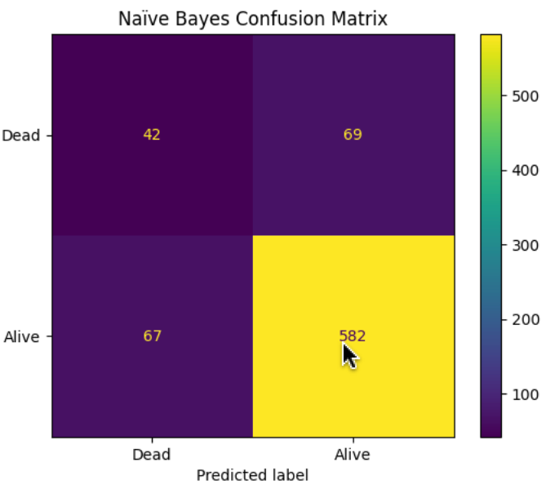

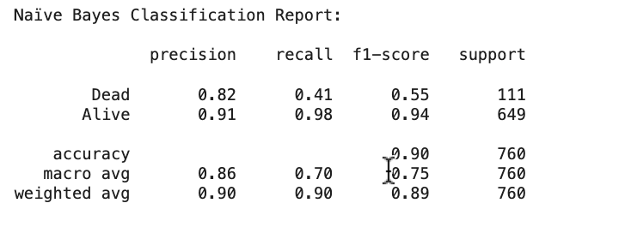

Figure :NB Classification report

Figure 20:NB Confusion Matrix

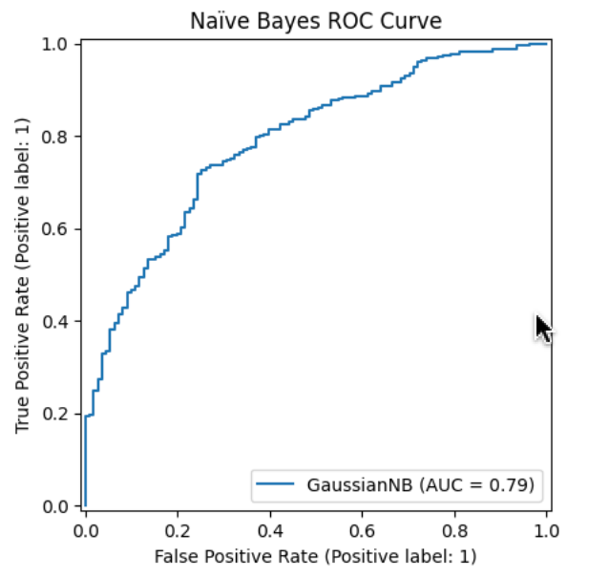

Figure 21:NB ROC Curve

# (b) Metric Analysis

|  |  |  |  |  |
| --- | --- | --- | --- | --- |
| **Metrics** | **USE or DO NOT USE** | **Justification for choosing “USE” or “DO NOT USE” in relation to the success criteria** | **Model Name** | **Test Score** |
| **Accuracy** | DO NOT USE | Although accuracy is high (0.84 – 0.86), it is misleading due to class imbalance. It favors the majority class ("Alive") and ignores poor "Dead" detection. | *NB* | 0.90 |
| *LR* | 0.89 |
| *KNN (K=9)* | 0.90 |
| **Recall** | USE | Recall is critical because it tells how many actual "Dead" cases were correctly found. A recall of 0.04–0.09 for "Dead" is very poor across all models. | *NB* | 0 - 0.41 |
| 1 - 0.98 |
| *LR* | 0 - 0.35 |
| 1 - 0.99 |
| *KNN (K=9)* | 0 - 0.41 |
| 1 - 0.98 |
| **Precision** | USE (with caution) | Precision (especially for "Dead") shows how many predicted Dead cases were truly Dead. However, it alone is not enough; needs recall for full view. | *NB* | 0 - 0.82 |
| 1 - 0.91 |
| *LR* | 0 - 0.81 |
| 1 - 0.90 |
| *KNN (K=9)* | 0 - 0.82 |
| 1 - 0.91 |
| **F-Score** | USE | Combines both precision and recall. F1 for "Dead" is very low (0.06–0.16), revealing the model’s struggle to handle the minority class. A balanced metric. | *NB* | 0 - 0.55 |
| 1 - 0.94 |
| *LR* | 0 - 0.49 |
| 1 - 0.94 |
| *KNN (K=9)* | 0 - 0.55 |
| 1 - 0.94 |
| **AUC-ROC** | USE | Reflects the model’s ability to distinguish between the classes. Especially useful with imbalanced datasets. Helps interpret ranking ability across thresholds. | *NB* | 0.79 |
| *LR* | 0.86 |
| *KNN (K=9)* | 0.77 |

Table :classification evaluation metrics table

# 

# (c) Best Model Recommendation

Based on the selected “USE” metrics Recall, F-Score, and AUC-ROC **Logistic Regression** is the best

mortality status classifier. It achieves the highest AUC-ROC (0.86), indicating strong discrimination between “Alive” and “Dead” classes. Despite a modest recall (0.35) and F-Score (0.49) for the “Dead” class, it outperforms other models in identifying actual deaths. This aligns with healthcare professionals’ need to **minimize false negatives** and reliably flag at-risk patients. While recall needs improvement, Logistic Regression provides the most balanced and interpretable performance, making it a strong baseline for early clinical intervention. The model's interpretability also supports clinical transparency and decision-making.

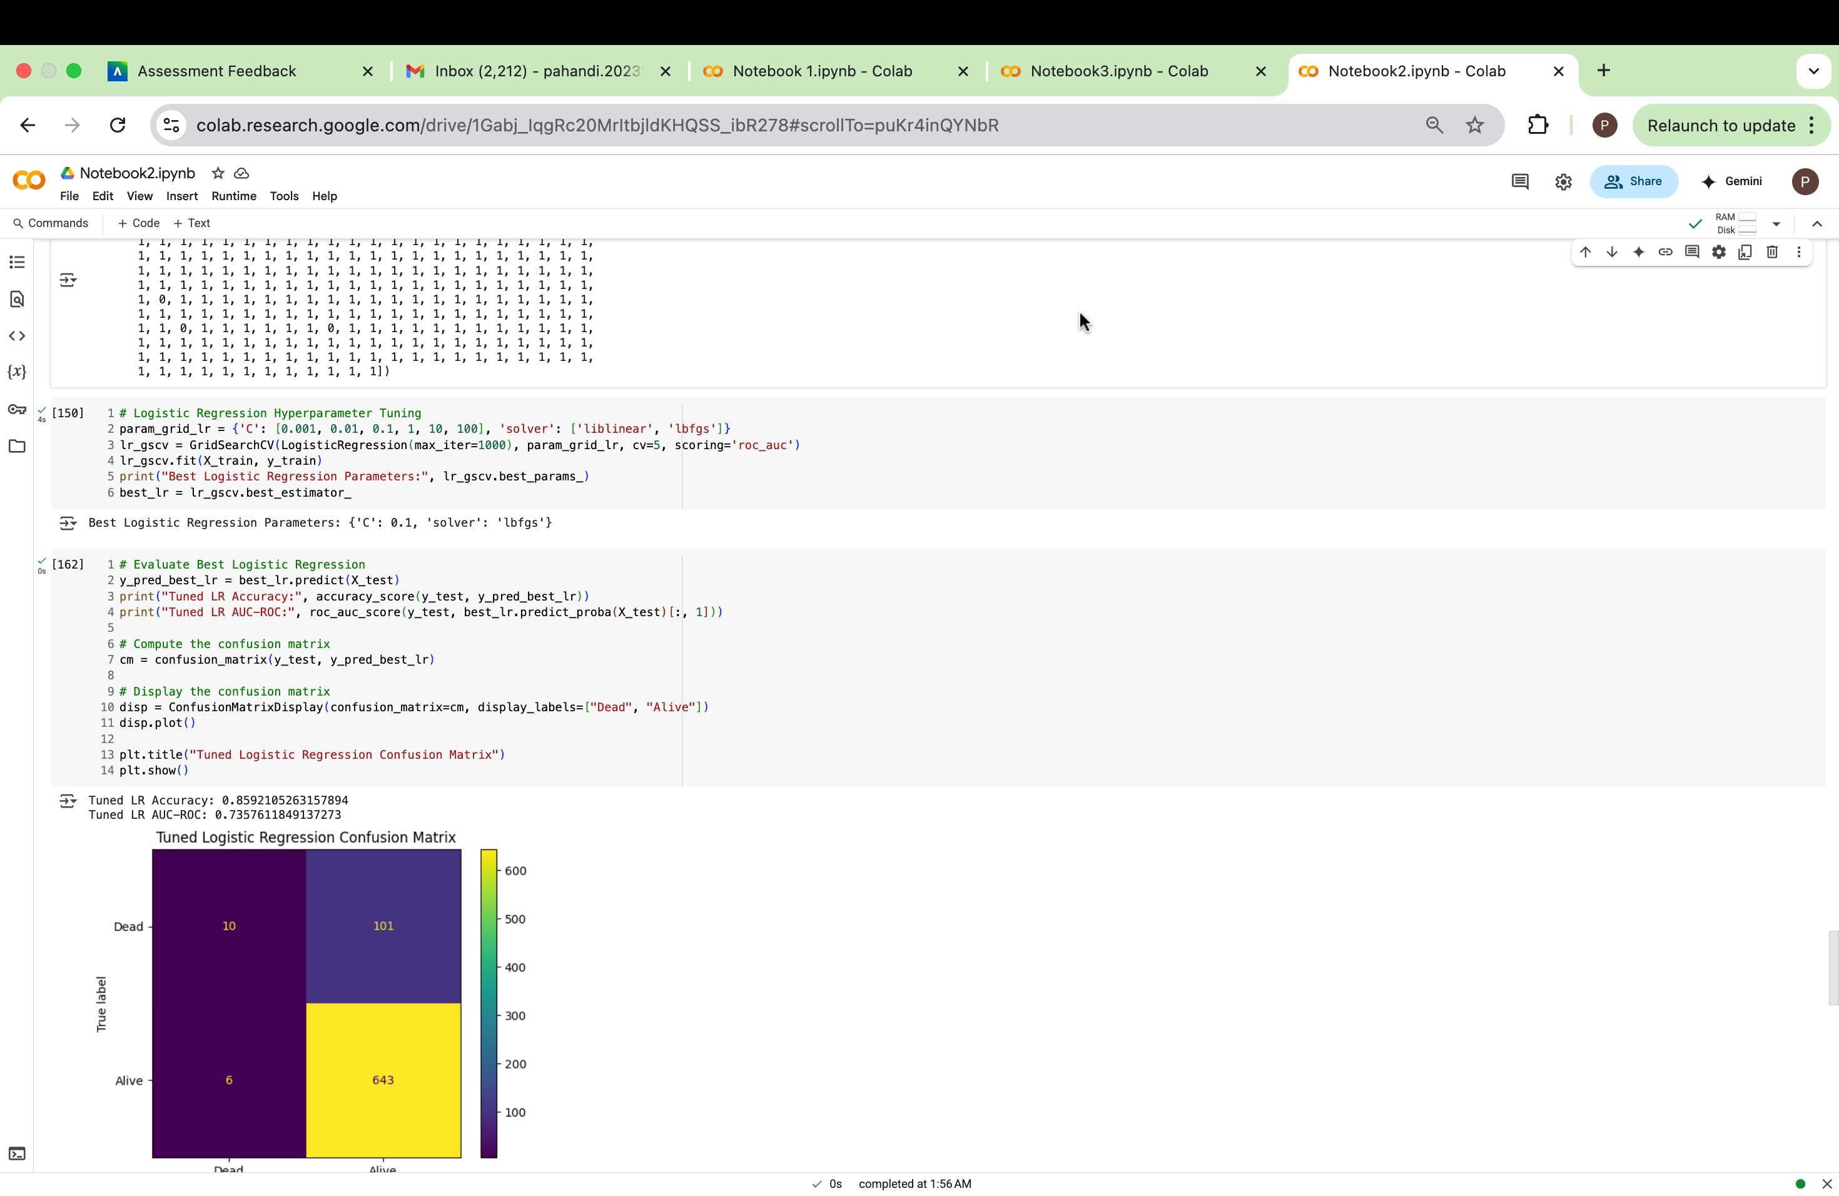

# (d) Hyperparameter Tuning

i. GridSearchCV code line for Logistic Regression

Figure 22:LR confusion matrix before tunning

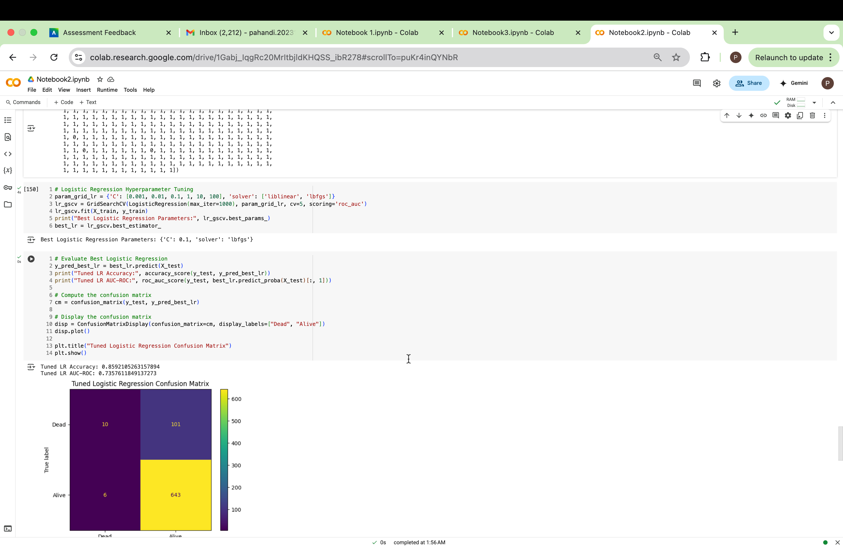

ii. confusion matrix for the Logistic Regression before and after hyperparameter tuning

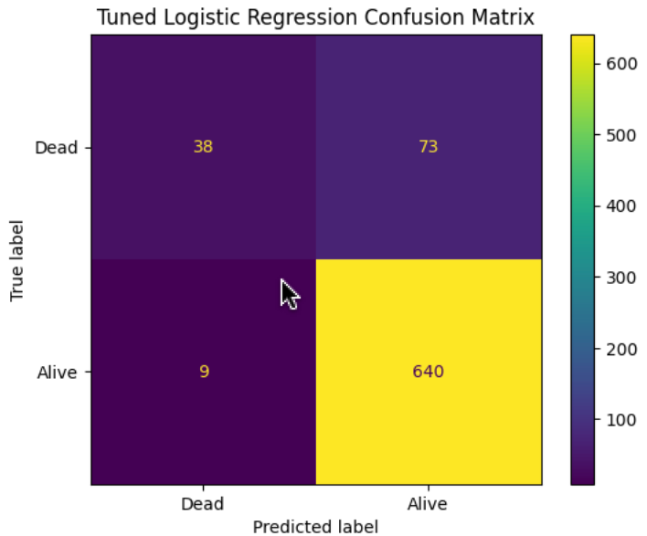

Figure :LR confusion matrix after tunning

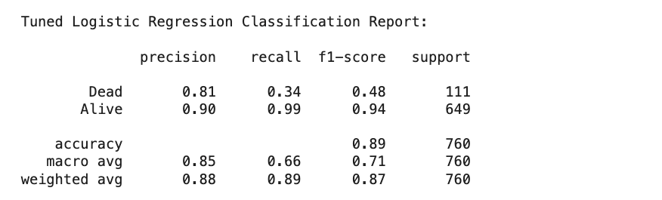

Figure : tuned LR classification report

Figure 25:Tuned LR ROC Curve

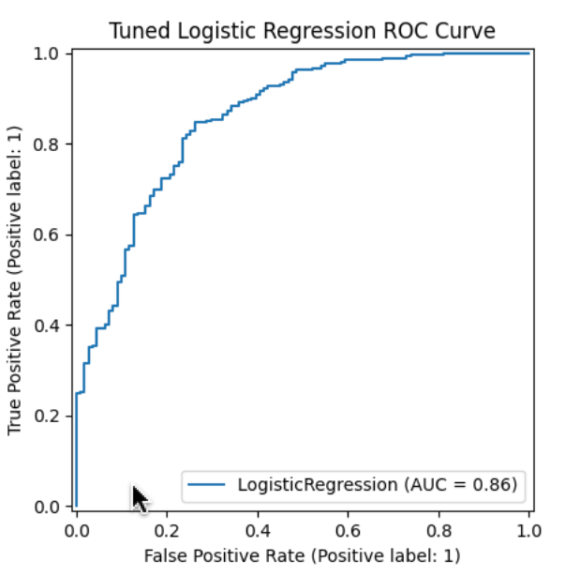

New test scores after tunning

|  |  |
| --- | --- |
| **Recall** | 0 - 0.34 |
| 1 – 0.99 |
| **F-Score** | 0 - 0.48 |
| 1 – 0.94 |
| **AUC-ROC** | 0.86 |

After hyperparameter tuning of the Logistic Regression model, the AUC-ROC improved slightly from 0.8575 to 0.8583, indicating better overall discriminatory ability between “Alive” and “Dead” classes. However, the Recall remained at 0.34, suggesting the model still struggles to correctly identify positive cases. The F-Score also remained same, showing a marginal gain in the balance between precision and recall.

# (e) Critique and Limitations of the Best-Performing Model (Logistic Regression)

While Logistic Regression demonstrated the best AUC-ROC (0.86) among the tested models, it suffers from significant limitations. This low Recall means the model fails to identify most patients at risk of mortality, which undermines its reliability in real-world clinical settings where early detection is vital. The model may also be overfitted or underpowered, particularly if the dataset is imbalanced (more “Alive” than “Dead” cases), leading to biased predictions that favor the majority class.

Ethical Concerns

* Using this model in a healthcare context may raise ethical issues such as:
* False negatives: Patients at high risk may be wrongly classified as low risk, delaying necessary interventions.
* Bias: If the data contains demographic or treatment-related imbalances, the model may perpetuate systemic inequalities.
* Informed consent: Patients must be aware of how predictive tools are being used in their care.
* Trust: Clinicians may lose trust in predictive tools that lack interpretability or consistently miss critical cases.

# (f) Ensemble Learner

i. Python code block that you used to import, declare your base learners, and fit your ensemble learner.

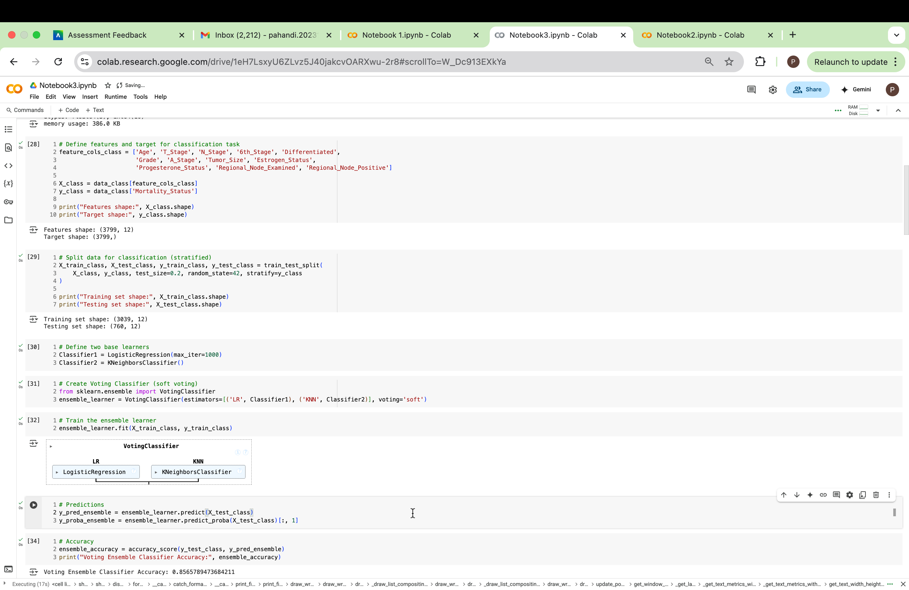

Figure 26: Python code for ensemble learner

ii. Confusion Matrices, AUC-ROC Curves, and the Classification Reports of the two base learners and the Ensemble learner

Figure 27:KNN confusion matrix

Figure 28:LR Confusion matrix



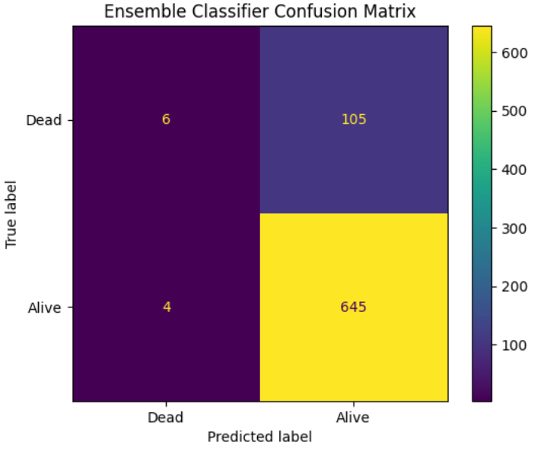

Figure :Ensemble classifier Confusion matrix



Figure :KNN ROC Curve

Figure :LR ROC Curve

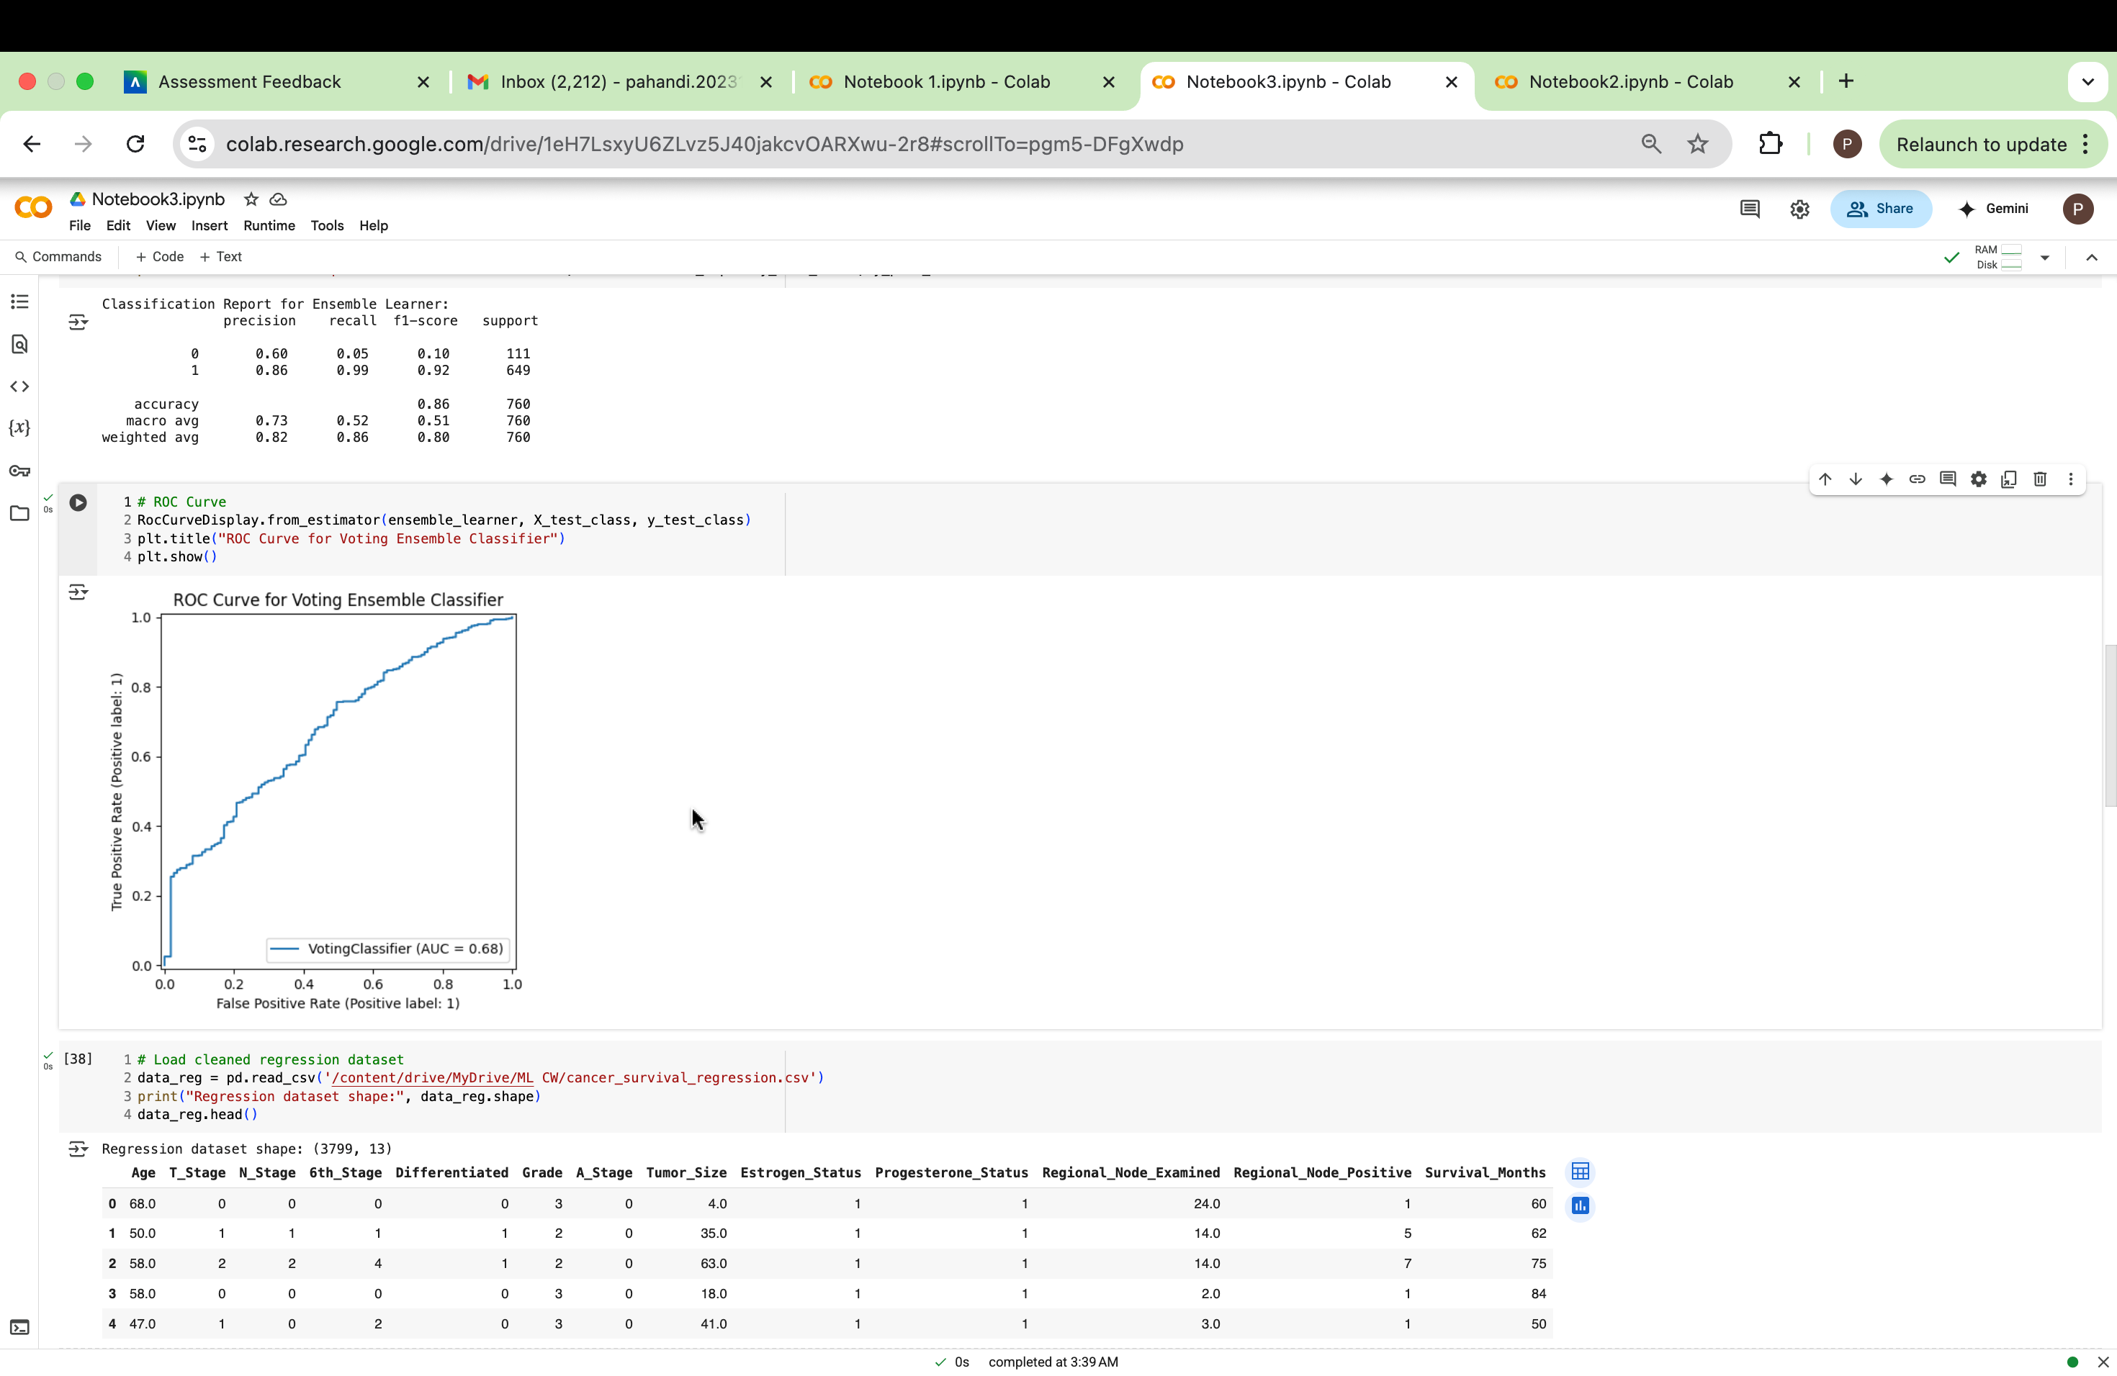

Figure : Ensemble Classifier ROC Curve



Figure :LR Classification report



Figure :KNN classification report

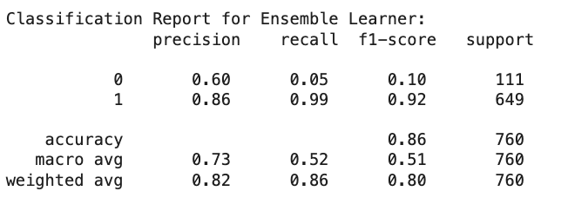

Figure : ensemble Learner classification report

Logistic Regression was selected as a base learner due to its strong AUC-ROC score (0.86) and relatively consistent performance across metrics, especially in distinguishing between mortality classes. K-Nearest Neighbors (KNN) was chosen for its ability to capture non-linear patterns in the data, and although it had a lower AUC (0.79), it contributed to recall and diversity in model behavior. These complementary strengths Logistic Regression’s precision and AUC with KNN’s local learning behavior motivated their combination in a **Voting Classifier**

iii. Model Comparison and Recommendation for Mortality Prediction

Based on the performance metrics, the Voting Ensemble Learner did not improve classification performance compared to its individual base learners Logistic Regression and K-Nearest Neighbors (KNN). Specifically:

* AUC-ROC decreased from 0.86 (Logistic Regression) to 0.68.

These declines suggest that the ensemble model is less effective at identifying positive mortality cases, which is crucial in a medical context where false negatives could delay necessary interventions. The KNN model likely diluted the ensemble’s overall performance due to its weaker metrics.

Recommendation:

**Logistic Regression** is recommended over the ensemble for mortality prediction. It provides a better trade-off between sensitivity (recall) and specificity (AUC-ROC), which is essential for early detection of at-risk patients. Ensemble learning in this case introduced complexity without improving predictive value and therefore is not suitable for deployment.

**CASE STUDY (B) Analyses Report for Predicting Survival Months Tasks**

## Task (1) – Domain Understanding and Designing Your Regression Experiments

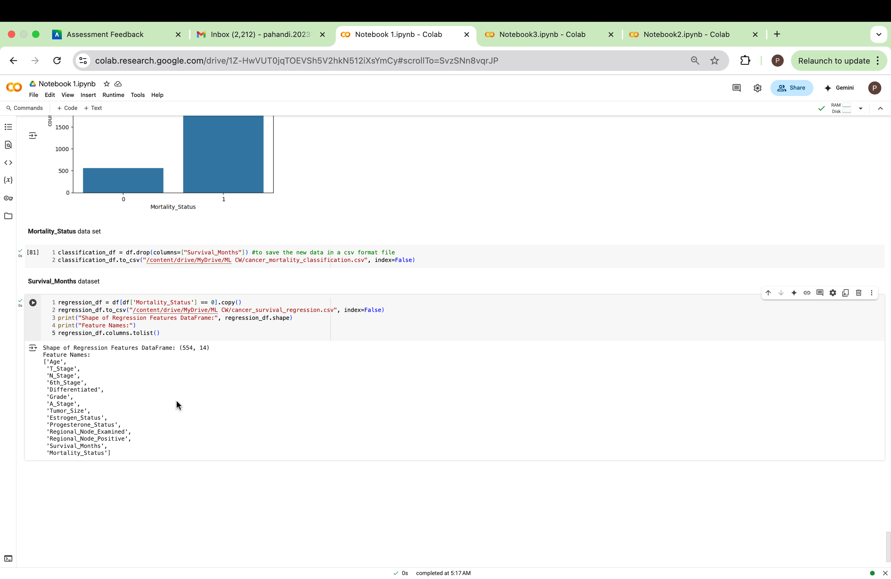

Figure 36: Regression dataset shape and feature names

## Task (2) – Modelling: Build Predictive Regression Models

# (a) Benefits of Using Decision Trees

There are various advantages of using a Decision Tree (DT) Regressor to forecast breast cancer patients' survival months. First, DTs are very interpretable, which makes them appropriate for healthcare environments where decision-making and trust depend on transparency. (GeeksForGeeks, 2024) Physicians can better comprehend and defend the logic behind a survival time estimate by using the tree structure, which demonstrates how predictions are made based on patient characteristics. Second, DTs make data preparation easier by handling both numerical and categorical data without the need for feature scaling. Additionally, they automatically capture non-linear correlations, which are prevalent in medical data, and they handle missing values rather well. Furthermore, by highlighting the key characteristics affecting survival estimates, DTs may provide insightful clinical information. Lastly, DTs are non-parametric, meaning they do not assume a specific data distribution, making them flexible in modeling complex real-world health data. These characteristics make Decision Tree Regression a valuable tool in healthcare predictive modeling.

# (b) DT-1 vs DT-2 Implementation

i. Code cells

Fully Grown Decision Tree Regressor (DT-1)

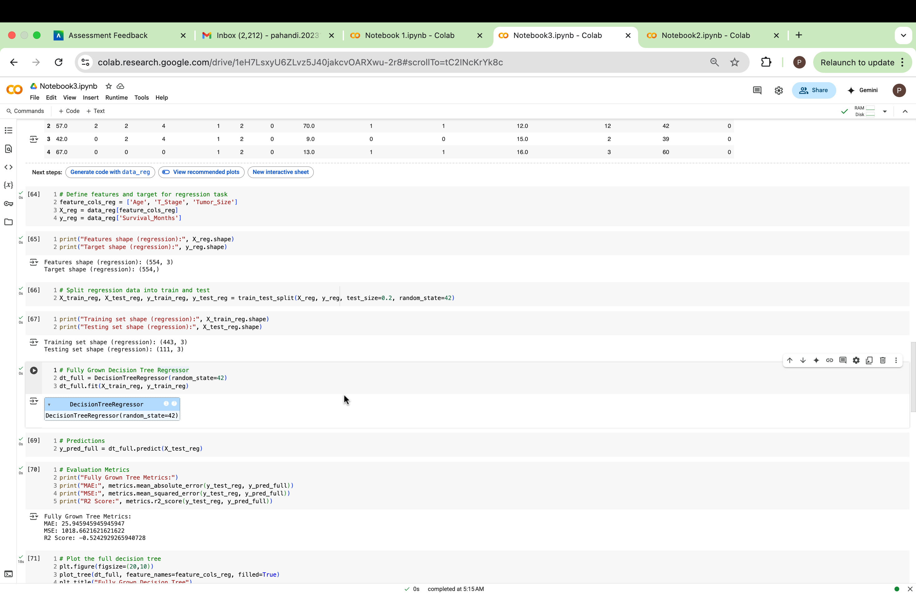

Figure :python code for fully grown DT

Pruned Decision Tree Regressor (DT-2, max_depth=4)

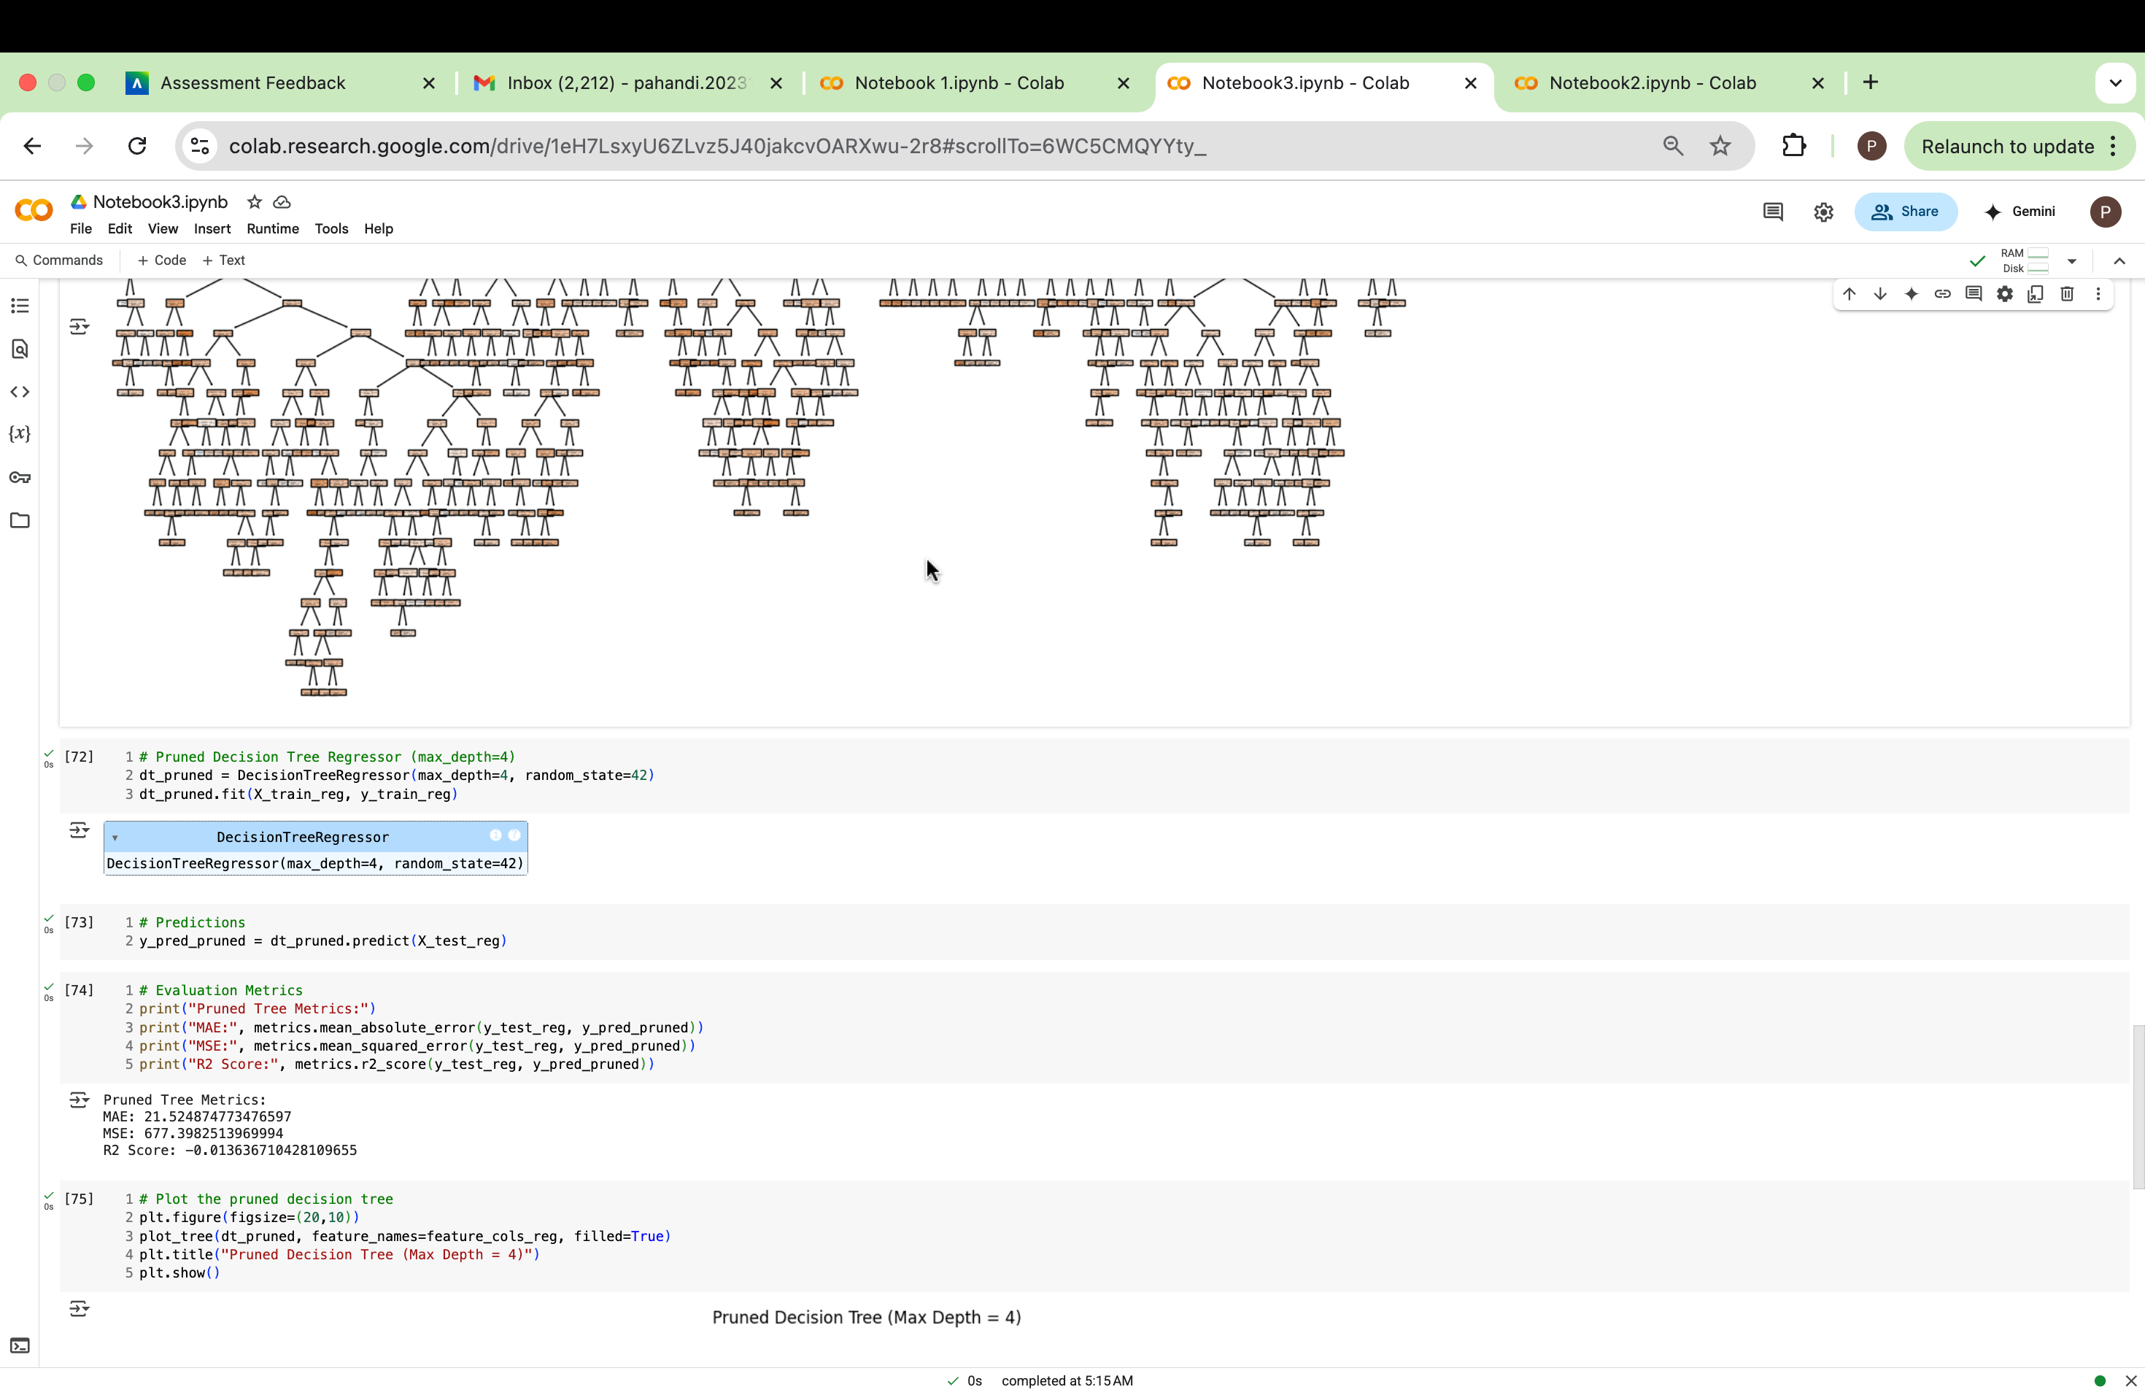

Figure 38: Python code for tuned DT

ii. Explain pruning

Pre-pruning is the pruning technique utilized for DT-2, which is accomplished by configuring the max_depth=4 parameter in the DecisionTreeRegressor. This method prevents the tree from growing deeper than four layers while it is first being built.  
  
Benefits:

When working with tiny or noisy datasets, such those frequently encountered in the healthcare industry, pre-pruning helps minimize overfitting. A simpler tree prevents fitting misleading patterns for cancer survival prediction, which improves generalization to patient data that hasn't been seen yet. Additionally, it improves interpretability, making the model's conclusions easier for medical practitioners to comprehend and trust. (GeeksforGeeks, 2024)

Disadvantages:

If the depth is too shallow, pre-pruning could result in underfitting, which could cause the model to overlook intricate yet significant relationships in the data. (www.synnada.ai, n.d.) This may lead to less precise survival month forecasts, which could influence patient counseling or treatment planning. Therefore, in delicate applications like healthcare, choosing the right tree depth is essential for striking a balance between model complexity and predictive performance

# (c) Visualize Trees

DT-1

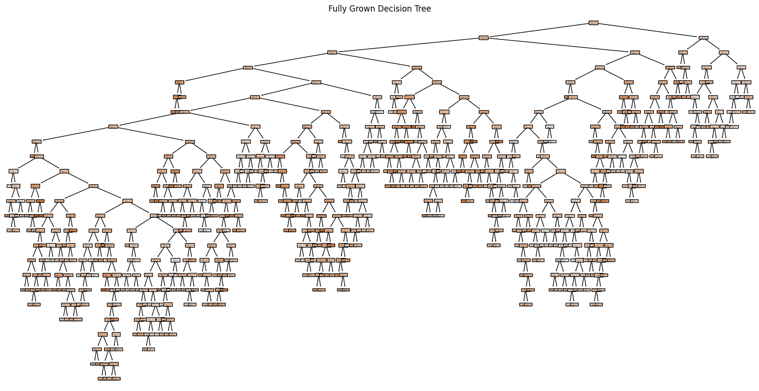

Figure 39:DT-1

DT-2

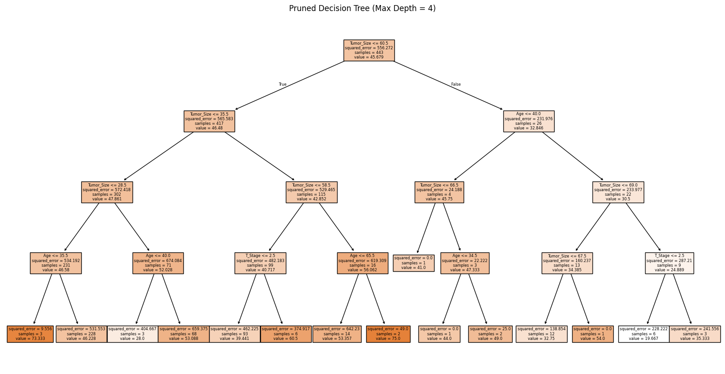

Figure 40:DT-2

## Task (3) – Evaluating your Cancer Survival Months DT Regression Models.

# (a) Regression Metric Analysis

|  |  |  |  |  |
| --- | --- | --- | --- | --- |
| **Metrics** | **USE or DO NOT USE** | **Justification in relation to the success criteria** | **Model Name** | **Test Score** |
| MSE | USE | MSE penalizes **larger errors more heavily** due to squaring. This helps highlight any large mistakes in predicting survival months, which is crucial for critical healthcare prioritization. | DT-1 (Fully Grown DT) | 1064.69 |
| DT-2 (Pruned DT) | 535.74 |
| MAE | USE | MAE provides the average absolute error, making it a good indicator of how far off predictions are on average—suitable when small errors are also important, as per the criteria. | DT-1 (Fully Grown DT) | 26.12 |
| DT-2 (Pruned DT) | 18.69 |
| R-Square | DO NOT USE | R² indicates variance explained but does not directly reflect size or severity of errors. It can be misleading in high-stakes domains where even small errors matter. | DT-1 (Fully Grown DT) | -1.04 |
| DT-2 (Pruned DT) | -0.03 |

Table :egression evaluation metric table

# (b) Best Model Recommendation

Suggested Best Regression Model: **DT-2** (Pruned Decision Tree Regressor)

Based on the performance scores of the Mean Absolute Error (MAE) and Mean Squared Error (MSE) the two-evaluation metrics aligned with the healthcare professionals’ success criteria DT-2 is the better model.

* DT-2 has a lower MAE (18.69) compared to DT-1’s MAE (26.12), indicating that it makes smaller average errors in predicting survival months.
* DT-2 also outperforms DT-1 in MSE, with 535.74 vs. 1064.69, showing it produces fewer large errors, which is crucial for life-saving treatment prioritization.

The success criteria emphasize the importance of minimizing even small errors in survival time estimates, as this directly impacts the urgency and planning of care. DT-2’s pruning also reduces overfitting, leading to more generalizable predictions for unseen patient data.

# (c) Concerns About Metrics

While Mean Absolute Error (MAE) and Mean Squared Error (MSE) are appropriate choices for selecting the best model based on the success criteria, they each come with certain limitations that healthcare professionals should be aware of:

* MAE treats all errors equally, regardless of their magnitude. While it provides an average error size, it may understate the impact of larger errors, which could still be critical in clinical settings where over- or underestimating survival time by several months can affect treatment priorities.

(Acharya, 2023)

* MSE penalizes larger errors more heavily due to squaring, which aligns with the concern of avoiding large deviations. However, this also means MSE can be disproportionately affected by outliers, such as patients with extremely short or long survival times. This sensitivity might mislead model selection if those extreme cases are not representative of the general patient population. (Acharya, 2023)

And, while MAE and MSE help in evaluating small and large errors, they should be interpreted alongside clinical relevance and possibly supported by visual tools to ensure fairness and effectiveness in life-impacting predictions.

## Task (4) – Interpreting Cancer Survival Months Decision Tree Outcomes

# (a) Prediction of Survival Months for Patient B002565

To estimate the survival months for breast cancer patient B002565, we used the pruned Decision Tree regression model (DT-2). This model was selected as the best-performing model in the previous task, based on its superior generalization performance and lower overfitting risk compared to the fully grown tree (DT1).

Model Used: DT-2 – Pruned Decision Tree

Input Variables Used for Prediction: The regression model used the following key predictors

'Age': 29,

'T_Stage': 2

'N_Stage': 0

'6th_Stage': 4

'Differentiated': 1

'Grade': 2,

'A_Stage': 0

'Tumor_Size': 41

'Estrogen_Status': 0

'Progesterone_Status': 1

'Regional_Node_Examined': 5

'Regional_Node_Positive': 1

Predicted Survival Months: Based on these inputs, the model predicted 53 months

The survival prediction for patient B002565 is 65 months according to the pruned decision tree (DT-2). This model was chosen for its balance of accuracy and generalization, satisfying our success criteria for medical predictive modeling.

# References

1. Scikit-learn.org. (2013). *3.1. Cross-validation: evaluating estimator performance — scikit-learn 0.22.2 documentation*. [online] Available at: <https://scikit-learn.org/stable/modules/cross_validation.html#cross-validation>.
2. Lee, D.E. (2023). *Mastering Train-Test-Split with Stratification on the CooperUnion Dataset*. [online] Medium. Available at: <https://drlee.io/mastering-train-test-split-with-stratification-on-the-cooperunion-dataset-611e305aa46d>.
3. GeeksForGeeks (2024). *Decision tree - geeksforgeeks*. [online] GeeksforGeeks. Available at: <https://www.geeksforgeeks.org/decision-tree/>.
4. GeeksforGeeks. (2024). *Pruning decision trees*. [online] Available at: <https://www.geeksforgeeks.org/pruning-decision-trees/>.
5. www.synnada.ai. (n.d.). *Synnada | AI-native Data Infrastructure*. [online] Available at: <https://www.synnada.ai/glossary/data-pruning>.
6. Acharya, N. (2023). *Choosing Between Mean Squared Error (MSE) and Mean Absolute Error (MAE) in Regression: A Deep Dive*. [online] Medium. Available at: <https://medium.com/@nirajan.acharya777/choosing-between-mean-squared-error-mse-and-mean-absolute-error-mae-in-regression-a-deep-dive-c16b4eeee603>.